1. The part list interfacing is as under

|  |  |  |
| --- | --- | --- |
| # | Electronic Interlocking | KAVACH |
| Make | KYOSAN | KERNEX |
| Model no |  |  |
| Interface type | RS232 | RS232 |
| Power Supply |  | 5V |
| Other modules |  |  |

1. Connection diagram:

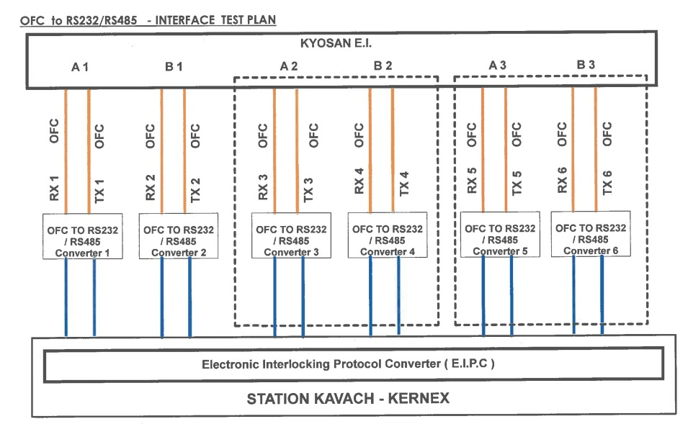

1. Is the power supply duplicated? **YES**
2. Is the communication duplicated? **YES**
3. Whether the communication is point to point? **YES**
4. Whether the communication is Peer to Peer OR Master - Slave? **YES**
5. Protocol Sequencing:



1. Is periodic health check available? **NO**
2. Is time synchronization available? **NO**
3. Entire Request – Response procedure is to be written down below: -
4. **KYOSAN-EI Sends Positive Control Information to the SKAVACH which contains RELAY statuses.**
5. **KYOSAN-EI Sends Positive Polling Information to the SKAVACH.**
6. **KYOSAN-EI Sends Negative Control Information to the SKAVACH which contains RELAY statuses.**
7. **KYOSAN-EI Sends Negative Polling Information to the SKAVACH.**

|  |  |  |
| --- | --- | --- |
| 4. | Periodicity and Timeout: |  |
| (i) | Whether the communication is periodic? | :**YES** |
| (ii) | What is the maximum rate of transfer of data? | : **38400 Baud rate** |
| (iii) | How many maximum number of data bits can be exchanged between EI and KAVACH? | : **480 Bits** |
| (iv) | The maximum round trip delay after which communication is said to be lost is | : **1 Second (Configurable)** |
| (v) | The KAVACH (Receiver) cycle time is | : **20 milli seconds** |

1. The Electronic Interlocking (Transmitter) cycle time is: **150ms**
2. The boot up time of Electronic Interlocking is :**120 Seconds**

(Is it Station – specific?) :**NO**

1. The boot up time of Stationary KAVACH is :**20 Seconds**

(Is it Station – specific?) :**NO**

1. Handling of duplicate messages:
2. How duplicate messages are detected?

**Not Applicable**

1. How duplicate messages are not processed?

**SKAVACH validates the reception of Positive and Negative Information’s in alternate cycles.**

1. Are duplicate messages stored in event logger?

By EI: **NO**

By SKAVACH: **NO**

1. Handling of out of sequences messages :NA
2. How out of sequence messages are detected?

**SKAVACH validates the reception of Positive and Negative Information’s in alternate cycles.**

N

1. How out of sequence messages are not handled?

**SKAVACH validates the reception of Positive and Negative Information’s in alternate cycles, if this cycle not happens for configured time then the messages will be discarded.**

1. Are out-of-sequence messages stored in event logger?

By EI: **NO**

By SKAVACH: **NO**

1. Communication Redundancy:
2. KAVACH is standalone system with: **2oo2.**
3. Is the Electronic Interlocking System Hot Standby or Warm Standby: **“Hot Standby”**

Electronic Interlocking system has “Single hardware architecture with diverse software” or 2oo2 hardware architecture: **“2oo2 Architecture”**

1. Schematic showing the communication arrangements without having impact original architecture of EI and SKAVACH is shown below: -



EI (P)

EI (S)

1. The entire message flow explaining communication redundancy is as under: -
   1. SKAVACH request to both EIs in hot/warm standby:

**both the systems of EI will keep on Sending the Control information (Relay statuses).**

* 1. Both EIs respond and reply: **Both EI’s will send Control Information (Relay statuses).**
  2. SKAVACH Validates: **SKAVACH will compare both the data, if both are same**

**it’ll be processed.**

1. Is the connection between EI and KAVACH direct: **YES**
2. If it is not direct, i.e., through a channel which is connected to other devices then the precautions taken to mitigate vulnerability and Interference shall be listed below:-

|  |  |  |  |
| --- | --- | --- | --- |
| # | Mitigation Measures | Phase of  mitigation | Responsibility  (EI/Kavach/Railways) |
| (i) |  |  |  |
| (ii) |  |  |  |
| (iii) |  |  |  |

1. (i) Is Tx sequence number available from EI side? **NO**
   1. Is Tx sequence number generated by EI unique? **NO**
   2. How is it unique? **Not Applicable**
   3. How S- KAVACH validated this?  **Not Applicable**
2. i) Is Tx sequence number available from SKAVACH side? **NO**
3. Is Tx Sequence number generated by SKAVACH unique? **NO**
4. How is it Unique? **Not Applicable**
5. How S-KAVACH validated this? **Not Applicable**
6. Time Stamp :-
7. Time stamping process of EI: **Through Railway Data logger**
8. Time stamping process of S-KAVACH:  **Through GPS**
9. Is time stamping process of EI and S-KAVACH same? **NO**
10. If time stamping is not same, the following are the steps taken to resolve the issue

1. How leap year is handled? **NO IMPACT on Communication**
2. It time Zone having impact on design? IST/GMT: **NO**
3. IP address: **It is RS-232 based serial communication IP addresses are not required.**
4. KAVACH system must ensure that the IP address provided by EI is only used for it’s system/PC which is connected to EI.
5. KAVACH system shall inform EI OEM about IP address which they use at their systems (This is to avoid any network conflict between both systems)
6. CRC :
7. What is the length of CRC of the Interface Protocol?

**16-Bit**

1. If it is less than 27 – bit, what techniques the OEM is following to meet the required level of THR for SIL-4? **By validating positive and negative control information.**
2. Version Control:
3. How version control of executive logic is managed in EI?
4. How version control of executive logic is managed in S-KAVACH?

**Executive logic files are maintained in a third party application called CLM (collaborative lifecycle management).**

1. How version control of application logic is managed when bits required to be sent are modified in EI?
   1. Does the CRC of application logic changes? **YES**
   2. If yes, how safety validation of application logic is ensured?

**As per the protocol it is not possible to detect the change in Application logic as there is no  
parameter, which provides details about application logic CRC/Version.**

* 1. What measures the Firm is planning to make it independent of Application logic CRC?

**As per the protocol it is not possible to detect the change in Application logic as there is no parameter, which provides details about application logic CRC/Version.**

* 1. How version control of data being sent through the EI-KAVACH Interface is ensured?

**As per the protocol it is not possible to detect the change in Application logic as there is no parameter, which provides details about application logic CRC/Version.**

* 1. If version control of data sent is not ensured what validation measures are taken by EI OEM to ensure safety?

**As per the protocol it is not possible to detect the change in Application logic as there is no parameter, which provides details about application logic CRC/Version.**

1. How version control of application logic is managed when bits required to be received are modified is S-KAVACH?

**Application logic files are maintained in a third party application called CLM (collaborative lifecycle management).**

* 1. Does the CRC of KAVACH TOC application logic change? **YES**
  2. If yes, how safety Validation of KAVACH TOC application logic is ensured?

**Application Logic shall be re-verified by a FAT with the independent V&V team.**

* 1. What measures the firm is planning to make it independent of KAVACH TOC application logic CRC?

**SKAVACH application logic depends on the relays statuses, presently no plans  
to make it independent.**

* 1. How version control of data being received through the Kavach – EI interface is ensured? **Application CRC’s of EI and SKAVACH shall be maintained.**
  2. If version control of data sent is not ensured, what validation measures are taken by KAVACH OEM to ensure safety?

**Application CRC’s of EI and SKAVACH shall be maintained.**

1. Grouping of Relays / Acquiring relay information: -
   1. EI shall indicate the total number of axle counters/ track circuits, points, lamp providing relays, other relays in a message. The message bytes shall be standardized and submitted to RDSO by KAVACH OEMs.

**Presently the Bit list is submitted to respective railway board.**

* 1. EI shall keep on sending all the relays status every cycle on the KAVACH Interface port: **YES, the Relay statuses are received at every message cycle.**
  2. This shall be a default activity in all new EI installations.
  3. The existing installations are also to be gradually migrated.
  4. The bit chest shall be provided to Railways by EI OEM.
  5. KAVACH OEM shall use this bit-chart and fetch the required relay information.

The test details shall be as under: -

* 1. The logs showing the status of relays between the Data logger output and port of KAVACH shall be compared for 30 days and SD shall be less than 10-8 in an hour. Report to be enclosed.